

Project Semester 4

Project Robot1: Using Agile with micro:bit Robot Control

Name: Chen Zhihan
NUIST ID: 202483890004
SETU ID: 20114295
Email: 3281941792@qq.com
GitHub URL: https://github.com/Mickchen123/ProjectRobot1_2026/
Demo Video URL:
https://pan.baidu.com/s/1g0j4Ux5zb-t7u-RGRSA3kQ?pwd=n52g

5/30/2026
Contents

1 THE AGILE PROCESS 2
1.1 Sprint 1: Foundation Building and Movement 3
1.2 Sprint 2: Directional Control and Remote Operation 4
1.3 Sprint 3: Speed Control and Predefined Path 5
1.4 Sprint 4: Finalization and Documentation 7
1.5 Burndown Chart 8
2 ROBOT PROJECT 11
2.1 Introduction 11
2.2 Implementation of the Project 11
2.2.1 Building the Robot 11
2.2.2 Robot Movement 12
2.2.3 Directional Control 13
2.2.4 Speed Control 14
2.2.5 Path Control 15
2.3 Git Commands 16
2.4 Video URL 16

1 THE AGILE PROCESS
This project adopts Agile Scrum methodology for iterative development of a micro:bit robot control system. The work is divided into four time-boxed sprints, focusing on incremental delivery, task prioritization, and continuous testing.

1.1 Sprint 1: Foundation Building and Movement
The first sprint mainly focuses on setting up the development environment (including GitHub repository and Python packages in order to draw burndown charts), assembling the hardware of the robot and trying to implement basic functions of the robot (including moving around). The user stories are as follows:
• User Story 1: As a developer, I want to set up the GitHub repository and configure the development environment, including installing required Python packages for burndown chart generation, so that the project can be managed and tracked effectively.
• User Story 2: As a developer, I want to assemble all hardware components of the micro:bit robot, including chassis, motors, motor driver and wiring, so that the physical robot is fully constructed.
• User Story 3: As a developer, I want to implement the basic movement functions of the robot, including moving forward and backward, so that the robot can perform simple motion.
The plan for sprint 1 is as follows:
Plan for Sprint 1
User Story ID | Description | Story Points | Responsible role
1 | Set up GitHub repository and install Python packages for burndown charts | 2 | Developer
2 | Assemble robot hardware and complete wiring | 7 | Developer
3 | Implement basic forward and backward movement | 5 | Developer
Burndown Table:

Burndown Table for Sprint 1
Working Hour | Ideal Remaining Story Points | Actual Remaining Story Points | Notes
0 | 14 | 14 | Sprint kickoff; tasks assigned
4 | 10.5 | 12 | GitHub repo created; environment setup completed
8 | 7 | 9 | Hardware assembly and wiring finished
12 | 3.5 | 5 | Basic movement code implemented and tested
16 | 0 | 0 | All Sprint 1 tasks completed

1.2 Sprint 2: Directional Control and Remote Operation
The second sprint focuses on extending the robot’s movement capabilities and enabling remote control via serial communication. The user stories are as follows:
• User Story 1: As a developer, I want to implement left and right turning functions, so that the robot can change direction.
• User Story 2: As a developer, I want to establish serial communication between the micro:bit and a computer, so that movement commands can be sent remotely.
• User Story 3: As a developer, I want to parse keyboard commands (F/B/L/R) into corresponding robot actions, so that the robot can be controlled manually.
The plan for sprint 2 is as follows:
Plan for Sprint 2
User Story ID | Description | Story Points | Responsible role
1 | Implement left and right turning functions | 4 | Developer
2 | Set up serial communication with the micro:bit | 3 | Developer
3 | Develop and test keyboard command parsing | 5 | Developer
Burndown Table:
Burndown Table for Sprint 2
Working Hour | Ideal Remaining Story Points | Actual Remaining Story Points | Notes
0 | 12 | 12 | Sprint kickoff; tasks assigned
2 | 10.5 | 11 | Turning logic drafted and initial testing started
4 | 9 | 10 | Turning functions implemented and verified
6 | 7.5 | 9 | Serial communication configuration completed
8 | 6 | 7 | Serial communication debugged and connection stabilized
10 | 4.5 | 6 | Keyboard command parsing logic written
12 | 3 | 4 | Command parsing tested and edge cases adjusted
14 | 1.5 | 2 | Full remote control system integrated
16 | 0 | 0 | All Sprint 2 tasks completed

1.3 Sprint 3: Speed Control and Predefined Path
The third sprint focuses on adding adjustable speed control and implementing an autonomous predefined path for the robot. The user stories are as follows:
• User Story 1: As a developer, I want to implement adjustable speed levels, so that the robot’s movement speed can be controlled based on different scenarios.
• User Story 2: As a developer, I want to design, code and calibrate a predefined path sequence (e.g., a square route), so that the robot can move autonomously without continuous manual input.
The plan for sprint 3 is as follows:
Plan for Sprint 3
User Story ID | Description | Story Points | Responsible role
1 | Implement adjustable speed control functions | 6 | Developer
2 | Design, code and calibrate predefined path logic | 7 | Developer
Burndown Table:
Burndown Table for Sprint 3
Working Hour | Ideal Remaining Story Points | Actual Remaining Story Points | Notes
0 | 13 | 13 | Sprint kickoff; tasks assigned
4 | 9.75 | 10 | Speed control logic implemented and initial calibration done
8 | 6.5 | 7 | Predefined path sequence drafted and first test run completed
12 | 3.25 | 3 | Path timing and turning accuracy adjusted
16 | 0 | 0 | All Sprint 3 tasks completed

1.4 Sprint 4: Finalization and Documentation
The fourth sprint focuses on finalizing the project code, organizing deliverables, and preparing all materials for submission. The user stories are as follows:
• User Story 1: As a developer, I want to refactor and comment the Python code, so that the project is clean, readable, and easy to maintain.
• User Story 2: As a developer, I want to organize all project files and push them to GitHub with meaningful commits, so that the complete version history is preserved.
• User Story 3: As a developer, I want to record and edit a demonstration video, so that all core functions of the robot can be clearly shown.
• User Story 4: As a developer, I want to complete the main project report and the socio-technical analysis report, so that all submission requirements are met.
The plan for sprint 4 is as follows:
Plan for Sprint 4
User Story ID | Description | Story Points | Responsible role
1 | Refactor and comment the Python code | 4 | Developer
2 | Organize project files and update GitHub repository | 3 | Developer
3 | Record and edit the demonstration video | 9 | Developer
4 | Complete the final reports | 7 | Developer
Burndown Table:
Burndown Table for Sprint 4
Working Hour | Ideal Remaining Story Points | Actual Remaining Story Points | Notes
0 | 23 | 23 | Sprint kickoff; tasks assigned
2 | 20.125 | 21 | Code refactoring and commenting started
4 | 17.25 | 18 | Code fully cleaned, commented and tested
6 | 14.375 | 15 | GitHub repository organized and final commits pushed
8 | 11.5 | 13 | Demo video recording completed
10 | 8.625 | 10 | Video editing, captions and trimming completed
12 | 5.75 | 7 | First draft of both reports completed
14 | 2.875 | 4 | Reports reviewed, revised and formatted
16 | 0 | 2 | Final checks of all deliverables in progress
18 | - | 0 | All deliverables completed and ready for submission

1.5 Burndown Chart
For this project, all 4 sprints maintained consistent progress: the actual completion line closely followed the ideal line, with only a minor 2-hour delay in Sprint 4 (due to final report formatting and video editing), which is within a reasonable range for delivery work. All planned user stories were delivered on schedule, meeting the project’s core objectives and submission requirements.
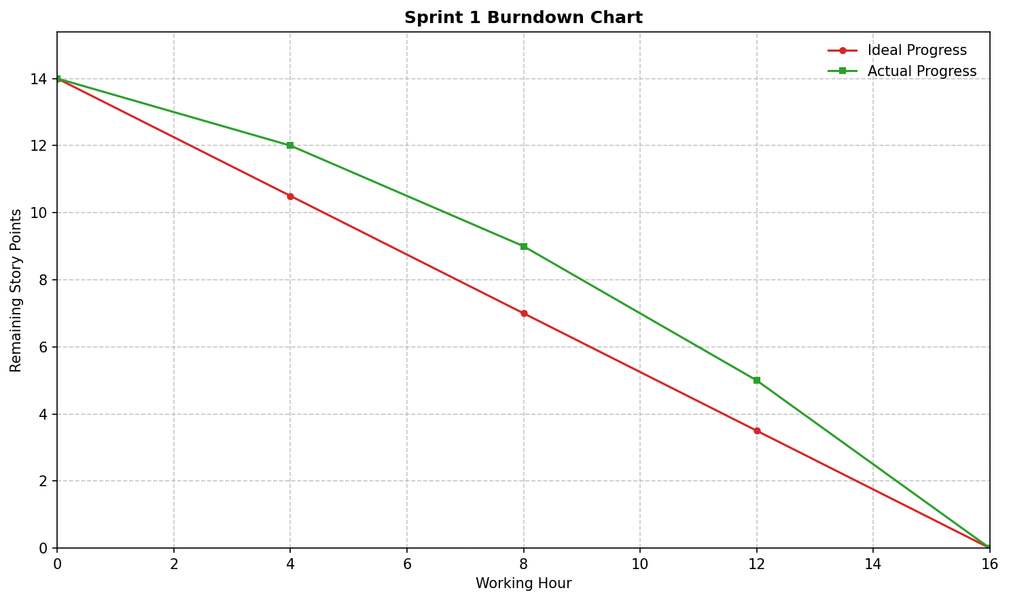
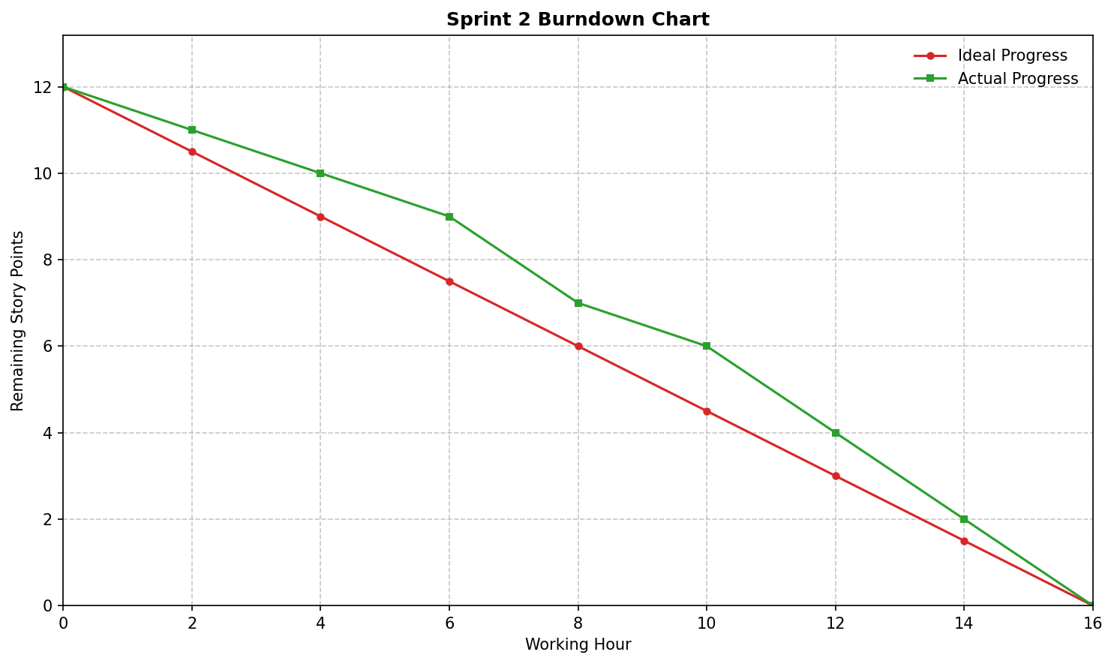
Each sprint’s burndown chart can be visualized as a line chart, with Working Hour on the x-axis and Remaining Story Points on the y-axis, using two lines to represent ideal and actual progress respectively.
*Generated through python package matplotlib

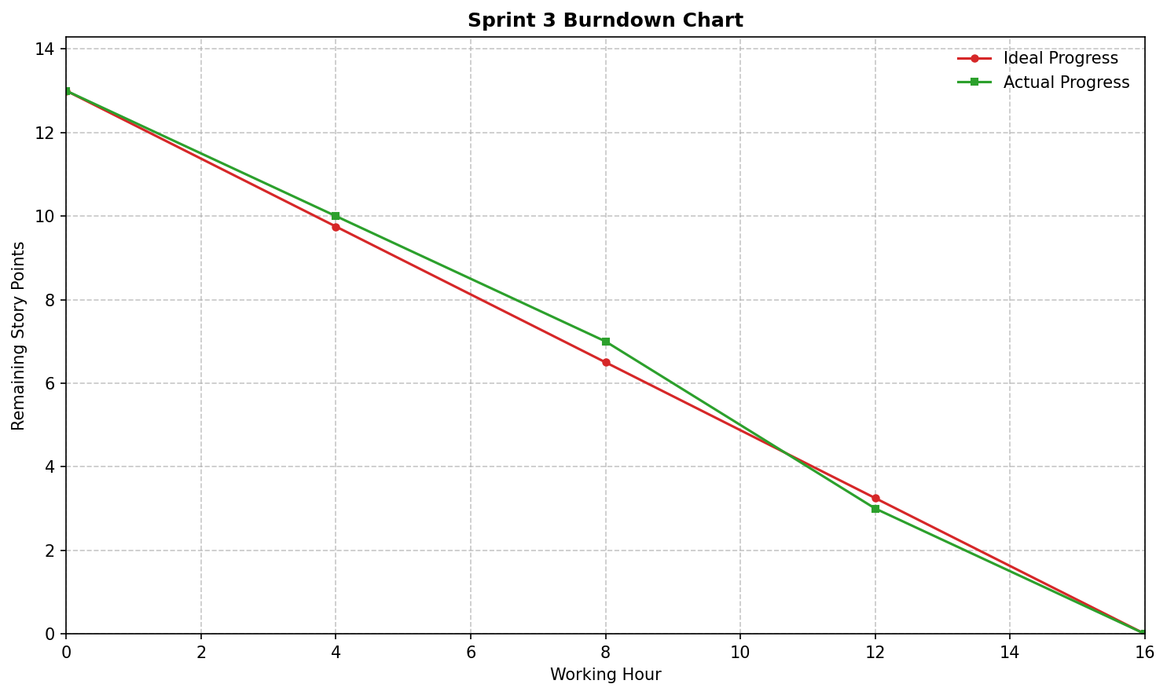

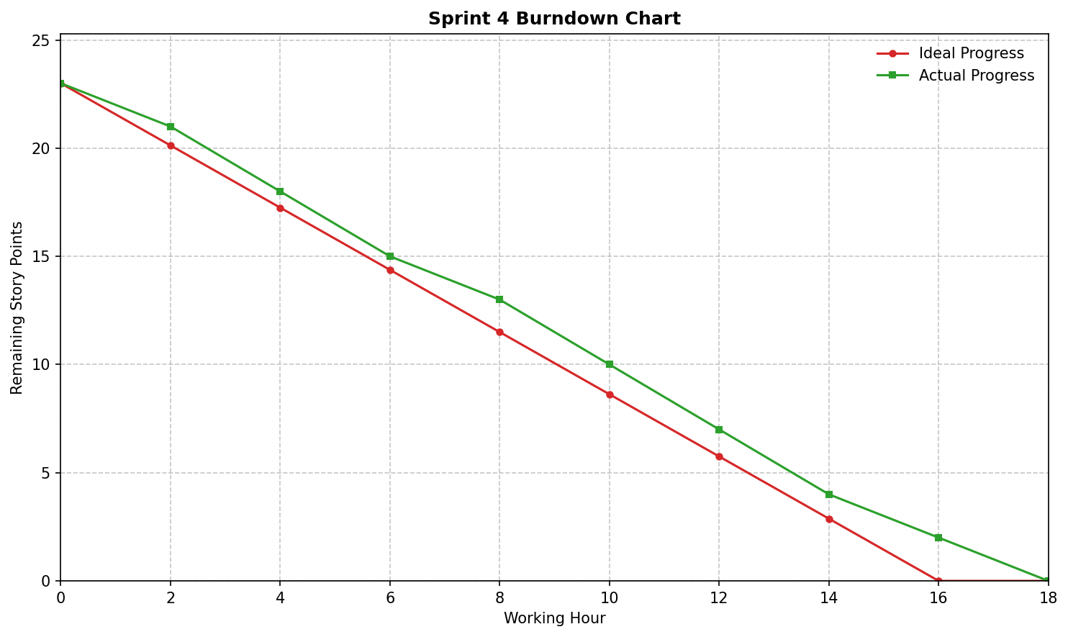

2 ROBOT PROJECT

2.1 Introduction
This project focuses on designing and implementing a control system for a micro: bit-based robot. The main objectives are to assemble the robot hardware, develop Python code for basic movements and directional control, and enable remote operation through serial communication. The project follows Agile Scrum methodology to ensure iterative development, systematic testing, and clear tracking of progress.

2.2 Implementation of the Project

2.2.1 Building the Robot
The robot is constructed using a micro: bit board, two DC motors, a motor driver module, a chassis, wheels, jumper wires, and a battery pack. The assembly process begins with attaching the motors to the chassis and securing the wheels. The motor driver is mounted on the chassis, and the micro: bit is connected to the motor driver using jumper wires. Finally, the battery pack is connected to power the entire system. All connections are carefully checked to ensure stable power supply and correct wiring.

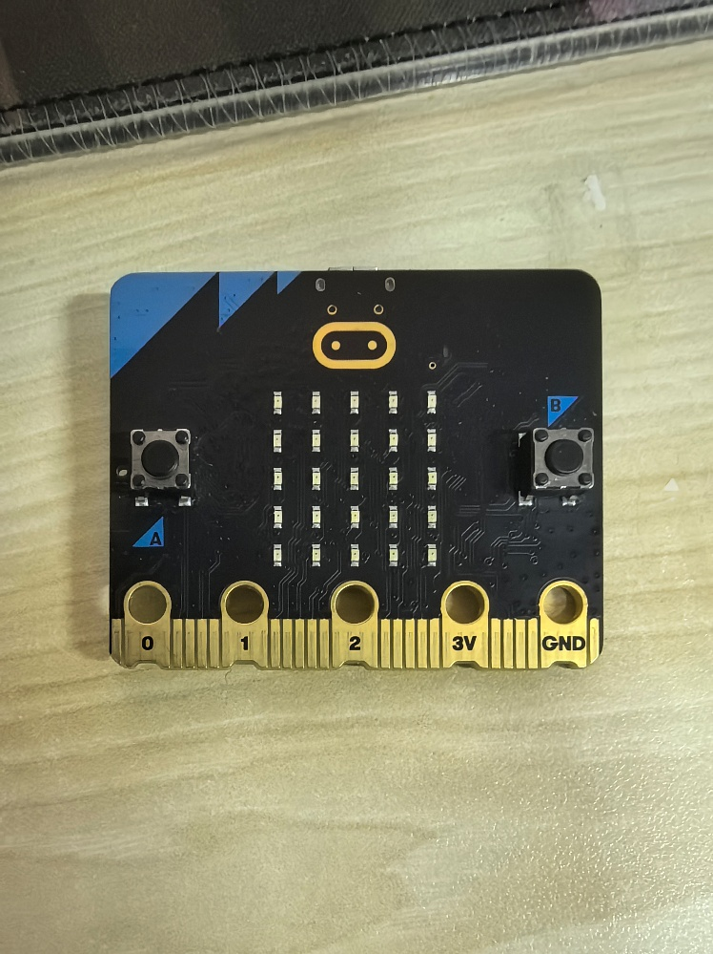

Micro: bit board

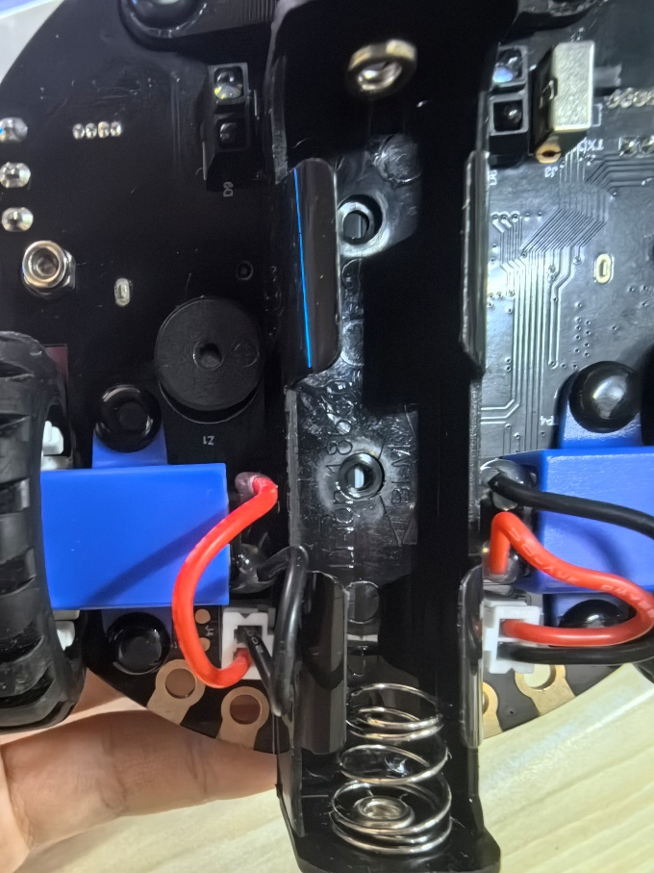

The chassis of the robot

2.2.2 Robot Movement
Basic movement functions are implemented to allow the robot to move forward and backward. The Python code sends control signals from the micro: bit to the motor driver, adjusting the motor rotation direction and speed. When moving forward, both motors rotate clockwise; when moving backward, both motors rotate counterclockwise. These functions are tested repeatedly to ensure smooth and stable movement without unexpected stops or jitters. The function is implemented through the modular programming software called MakeCode for microbit. By simply dragging modules we can make the car move around, then we download the .hex file and drag it to the board, then it will automatically execute the program.
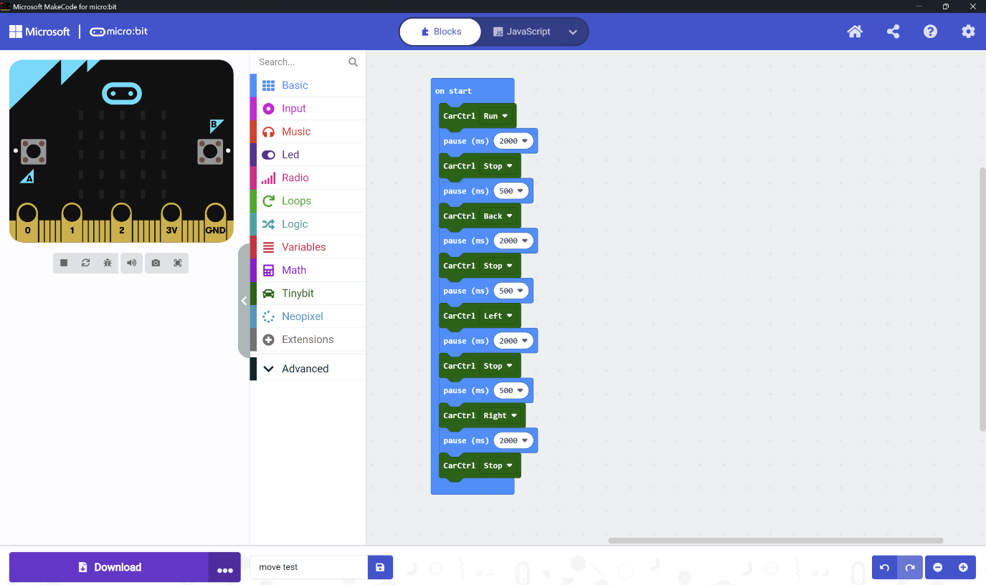
Interface of MakeCode for microbit

2.2.3 Directional Control
There are multiple ways to control the direction of the car. Including direct programming to burn programs into the board for the car to automatically execute the programs on the board or controlling the direction of the car's movement through third-party software such as Bluetooth on a mobile app or controller. Due to practical operational requirements, we can choose the first option to directly burn the written program onto the board, which will facilitate our subsequent operations.

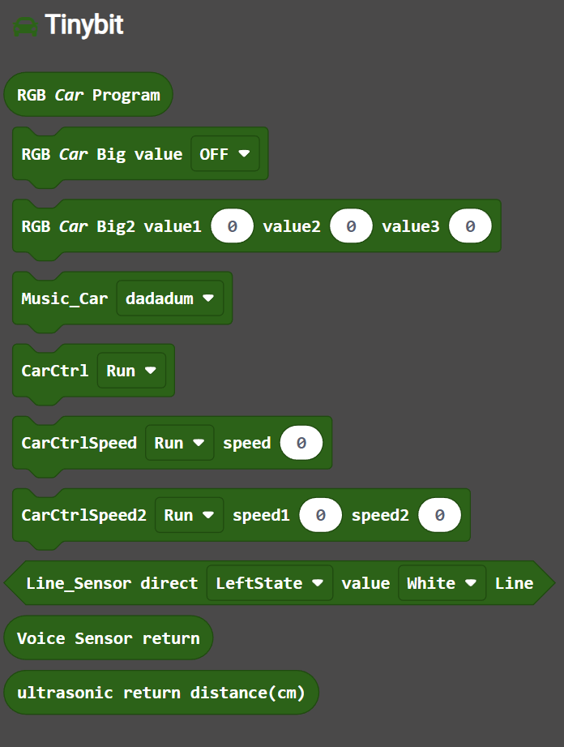

Modules of Tinybit

2.2.4 Speed Control
Similarly, if we want to control the speed of the car, we only need to drag the module that controls the speed of the car in Tinybit. This module can control the speed of single-sided or double-sided motors, thereby achieving the control of the speed of the car.
Tinybit.car_ctrl(Tinybit.CarState.CAR_RUN)
basic.pause(2000)
Tinybit.car_ctrl(Tinybit.CarState.CAR_STOP)
basic.pause(500)
Tinybit.car_ctrl(Tinybit.CarState.CAR_BACK)
basic.pause(2000)
Tinybit.car_ctrl(Tinybit.CarState.CAR_STOP)
basic.pause(500)
Tinybit.car_ctrl(Tinybit.CarState.CAR_LEFT)
basic.pause(2000)
Tinybit.car_ctrl(Tinybit.CarState.CAR_STOP)
basic.pause(500)
Tinybit.car_ctrl(Tinybit.CarState.CAR_RIGHT)
basic.pause(2000)
Tinybit.car_ctrl(Tinybit.CarState.CAR_STOP)
Source Code of Basic Movement

2.2.5 Path Control
If we want to achieve the automatic line inspection function of the car, we can also directly drag the module in Tinybit, which needs to call the car's color sensor. When the car recognizes the line of the color we specified, it will trigger the automatic line patrol function. In essence, the function is done by this logic: When the left sensor detects black while the right sensor detects white, that means the car needs to turn left to make sure the car is still driving with both sensors detecting white background. Left is white and right is black is same logic.
def on_forever():
if Tinybit.Line_Sensor(Tinybit.enPos.LEFT_STATE, Tinybit.enLineState.WHITE) and Tinybit.Line_Sensor(Tinybit.enPos.RIGHT_STATE, Tinybit.enLineState.WHITE):
Tinybit.car_ctrl_speed2(Tinybit.CarState.CAR_RUN, 30, 30)
elif Tinybit.Line_Sensor(Tinybit.enPos.LEFT_STATE, Tinybit.enLineState.BLACK) and Tinybit.Line_Sensor(Tinybit.enPos.RIGHT_STATE, Tinybit.enLineState.WHITE):
Tinybit.car_ctrl_speed2(Tinybit.CarState.CAR_RUN, 20, 110)
elif Tinybit.Line_Sensor(Tinybit.enPos.LEFT_STATE, Tinybit.enLineState.WHITE) and Tinybit.Line_Sensor(Tinybit.enPos.RIGHT_STATE, Tinybit.enLineState.BLACK):
Tinybit.car_ctrl_speed2(Tinybit.CarState.CAR_RUN, 110, 20)
else:
Tinybit.car_ctrl_speed2(Tinybit.CarState.CAR_RUN, 30, 60)
basic.forever(on_forever)
Source Code of Path Control
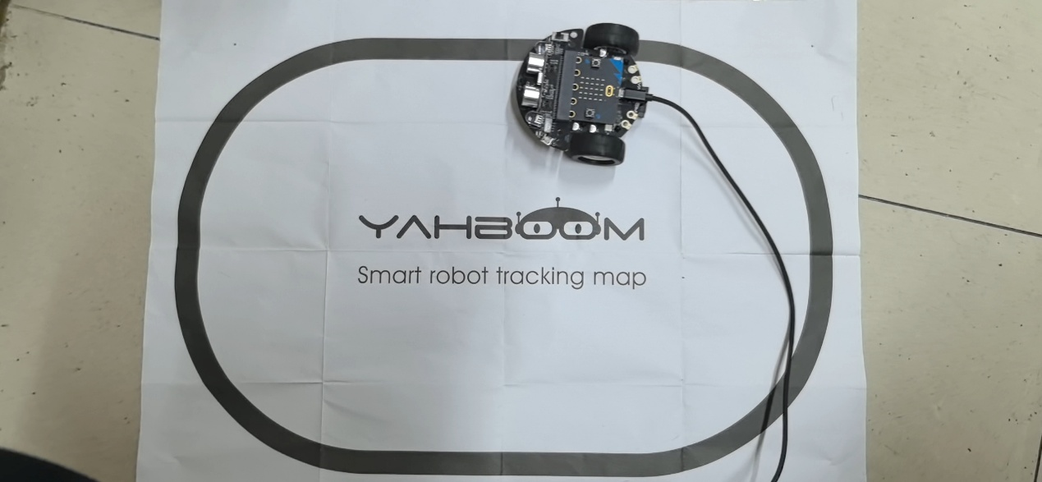
The car is automatically patrolling the black line

2.3 Git Commands

2.4 Video URL
Video link for presentation:
https://pan.baidu.com/s/1g0j4Ux5zb-t7u-RGRSA3kQ?pwd=n52g

